URBAN STORM WATER MANAGEMENT FOR CITIES BUILT UPON KARST:
BOWLING GREEN, KENTUCKY, USA

Gina Lee Cesin*
Nicholas C. Crawford
Center for Cave and Karst Studies
Applied Research and Technology Program of Distinction
Department of Geography and Geology
Western Kentucky University
Bowling Green, Kentucky USA

Abstract

Cities built upon well-developed karst have serious problems associated with storm water management, such as, sinkhole flooding, groundwater contamination from storm water runoff, spills of toxic chemicals, and storm water induced regolith collapse sinkholes. Bowling Green, Kentucky, with a population of about 60,000, is a city located entirely upon a sinkhole plain with virtually all storm water runoff flowing into the cave streams that drain the city. This paper discusses sinkhole flooding problems, regolith collapse sinkholes induced by storm water runoff and storm water quality issues. The Center for Cave and Karst Studies (CCKS) has assisted the city of Bowling Green and Warren County with its karst environmental problems since it was established within the Department of Geography and Geology in 1978. Research discussed in this paper includes the use of dye traces combined with water table measurements to determine the general flow routes of cave streams that drain the karst aquifer beneath the city. The CCKS has also mapped the accessible caves under the city and located the general route of other caves by using the geophysical techniques of microgravity and electrical resistivity. The CCKS has prepared a GIS map showing springs, karst windows, caves and other karst features. The map also shows the general flow routes taken by cave streams as determined by over 100 dye tracer tests. It also shows the contours for the water table surface beneath the city and the groundwater basin catchment area boundaries for the major springs. The paper discusses the storm water management plan enacted by the Bowling Green – Warren County Planning Commission in 1976 that prohibits construction within sinkhole flood plains and requires storm water retention basins. Two case studies are presented where the CCKS has assisted the city with sinkhole flooding problems and the removal of contaminants from storm water runoff.

Sinkhole Flood Plains

Bowling Green, Kentucky is located entirely upon a sinkhole plain with virtually all of the storm water runoff flowing into the cave streams that drain the city. Virtually all of the city is located on the Mississippian Ste. Genevieve Limestone which is characterized by large, shallow sinkhole basins with large catchment areas for storm water runoff. This low relief sinkhole plain has resulted in serious sinkhole flooding problems throughout much of the city. Just to the east of the city the underlying St. Louis Limestone outcrops and is characterized by numerous large, deep sinkholes. This high relief sinkhole plain has few problems associated with sinkhole flooding because the catchment areas are smaller, and the bottoms of the sinkholes are obvious. Therefore, people have not built houses or buildings in the sinkhole flood plain, and this area is presently characterized by low-density, suburban development or farmland.

The sinkhole flooding problem within the city was addressed by the Bowling Green – Warren County Planning Commission when they enacted their Storm Water Management Plan in 1976. This plan requires that any time there is a land use change within the County, an engineering consulting firm must prepare a storm water management plan that delimits the sinkhole flood plain elevation for all the sinkholes that would be impacted by the land use change. The sinkhole flood plain is defined as the flood elevation in each sinkhole that would result from a 100-year probability three-hour storm event. This is equal to 10.2 cm (4 in) of precipitation falling in three hours. No consideration is given for any drainage out of the sinkhole in calculating the sinkhole flood plain elevation even though many sinkholes have open throats or cave entrances and therefore do not flood. No permanent structures are permitted within 0.3 m (1 ft) of the sinkhole flood plain elevation. If the land use change is to occur on property that does not drain into a sinkhole but rather flows onto adjacent property, then the land owner is required to construct a storm water retention basin capable of holding the increased runoff resulting from the land use change. The storm water management plan has greatly decreased sinkhole flooding in areas that have been developed since 1976. However, the older part of the city still has serious problems, so much so that the people with homes and buildings located in twenty sinkholes are eligible for federally subsidized flood insurance. Also, the city has obtained several grants from the Federal Emergency Management Agency (FEMA) to purchase and remove homes that are located in designated sinkhole flood plains.

Drilled Drainage Wells

For many years Bowling Green has attempted to alleviate sinkhole flooding by drilling storm water drainage wells to permit storm water to drain down into the karst aquifer. The U.S. Environmental Protection Agency (USEPA) considers these wells to be Class V Storm Water Injection Wells. There are now over 1,000 such wells within the urban area, and new ones are continuing to be installed. The wells are typically 20-25 cm (8-10 in) in diameter and are only cased to bedrock. They then extend as open boreholes down into the limestone. Although these wells rarely intersect caves, the great majority do intersect solutionally-enlarged bedding plane partings that direct the runoff into the network of cave streams beneath the city. These wells typically do not have the capacity to prevent sinkhole flooding in sinkholes with large catchment areas although they do facilitate drainage into the karst aquifer and reduce the sinkhole flood duration time. Many do have the capacity to reduce or eliminate sinkhole flooding in sinkholes with small catchment areas.

Constructed Drainage Wells

Increased storm water runoff due to urban development often results in induced regolith collapse sinkholes (cover collapse sinkholes). These sinkhole collapses tend to occur during flood events in places where increased storm water sinks through the regolith into a vertical crevice in the underlying limestone. These bedrock crevices are places where regolith water sinks down into the karst aquifer. The water table is typically about 18 m (60 ft) above the top of bedrock. There is usually a regolith arch or dome over the top of these bedrock crevices, and these tend to be stable until land use changes increase the amount of water percolating downward above the arch, causing the arch to collapse. If the arch collapses all the way to the surface, it results in a steep-sided hole typically 3.7 m (12 ft) wide and 3.7 m (12 ft) deep. The high clay content of the regolith in the Bowling Green area often results in the vertical walls observed in the sinkhole collapses. In areas where depth to bedrock is shallow, numerous small diameter collapses tend to occur. In areas where the depth to bedrock is deep, there tends to be fewer, but larger diameter collapses. In the Bowling Green area, even the largest collapses are rarely more than 10.7 m (35 ft) in diameter. Most of the collapses tend to occur along ditches and in the bottoms of bowl-shaped sinkholes where water stands after hard rains. Although the regolith collapse sinkholes are numerous, they rarely occur under homes or buildings in the Bowling Green area. Sometimes the ones that occur along ditches do impact the adjacent highway. Since the great majority of the collapses tend to occur near the bottoms of bowl-shaped sinkholes and along ditches, they are often used to direct storm water into the karst aquifer. The collapse identifies an open vertical crevice down into the karst aquifer. These collapses are, therefore, often excavated to bedrock to expose the crevice, and a well is then constructed, sometimes several meters (feet) in diameter, to direct storm water runoff into the vertical crevice.

Caves and Open Throat Sinkholes

Since Bowling Green is built entirely upon a sinkhole plain, virtually all storm water runoff sinks directly into the karst aquifer at thousands of locations. At some of these locations, the city has directed additional storm water runoff into cave entrances and open throat sinkholes.

Storm Water Quality

In the well-developed karst of Kentucky, cave streams are quite comparable to surface streams. Storm water runoff flows directly into caves at swallets and at numerous open throat sinkholes on the sinkhole plain. Therefore, the cave streams function as storm sewers just as surface streams also function as storm sewers in non-karst areas. Cities over 100,000 population have been required for several years by USEPA to test, and if need be, to treat storm water runoff in an attempt to increase the water quality of surface streams. Two years ago, USEPA extended these regulations to all towns within the U.S. with populations of 10,000 or more. Therefore, Bowling Green, with a population of approximately 60,000, is now required to meet USEPA Phase II Storm Water Management Plan regulations. The city has recently passed a tax increase and hired five people just to deal with storm water quality. The USEPA is still permitting the direct injection of storm water runoff into the karst aquifer beneath the city, but like other towns with more than 10,000 population, Bowling Green must now test its water quality and take steps to improve the quality of storm water runoff. The Center for Cave and Karst Studies (CCKS) has assisted the city and county with sinkhole flooding problems, sinkhole collapses and groundwater quality issues since it was founded in 1978. The faculty and professional staff and students associated with the CCKS are now actively involved in assisting the city to meet the USEPA Phase II Storm Water Management Plan regulations.
Groundwater Flow Map of Bowling Green

A GIS map showing the approximate groundwater flow routes within the karst aquifer in the vicinity of Bowling Green was prepared based upon: 1) dye traces, 2) cave maps, 3) caves located by microgravity and electrical resistivity, and 4) water table measurements. This map represents research performed by the faculty, professional staff and students of the CCKS since 1978. The numerous dye traces are shown as red lines on the map. Water table elevation contours as estimated from measurements taken at: 1) open borehole water wells, 2) storm water drainage wells that extend below the water table, 3) cave streams, 4) springs, and 5) surface streams are shown as blue lines. The approximate groundwater basin catchment boundaries based upon the dye traces and water table elevations are shown as dashed green lines. The map identifies the approximate groundwater flow routes to springs for the following major groundwater basin catchment areas: 1) Lost River, 2) Graham Springs, 3) Hobson Grove Springs, 4) Double Springs, 5) Mt. Ayr Blue Hole and Bluff Springs, and 6) Harris Spring. Included on the map are dye trace and water table contours northeast of Barren River performed by Dr. James Quinlan and Mr. Joe Ray (1981, revised 1989). This compilation of karst groundwater data onto one map was prepared to assist the City of Bowling Green in meeting the USEPA Phase II Storm Water Management Plan requirements and to assist Bowling Green with emergency response to any future spills of hazardous liquids. A poster paper authored by Brewer and Crawford (2005), entitled, “Groundwater Basin Delineation by Dye Tracing, Water Table Mapping, Cave Mapping, and Geophysical Techniques: Bowling Green, Kentucky, USA”, is presented at this conference.

Case Study: Egypt Parking Lot

One serious sinkhole flooding problem occurred in the vicinity of the Egypt Parking Lot at Western Kentucky University. After heavy rains, the sinkhole flooding covered not only the Egypt Parking Lot but also a major highway. This sinkhole has flooded repeatedly over the past 50 years, and during the last large flood, over eighty cars were inundated. Two storm water drainage wells had been drilled in the past in an attempt to alleviate the flooding. The wells did not help, and they actually resulted in increased contamination of the karst aquifer by receiving the first flush of storm water during every storm event. The CCKS investigated the problem for the University, the city of Bowling Green, and the Kentucky Department of Transportation. Dye tracer tests and water table mapping indicated that the large Lost River Cave was located near the vicinity of the flooding problem. Microgravity and electrical resistivity traverses were made perpendicular to the hypothesized route of Lost River Cave (Crawford, Fryer and Calkins, 2000). Exploratory borings were made into prominent low-gravity, high-resistivity anomalies. These borings intersected the large Lost River Cave. With the cave location established at one location, other traverses were performed in a “leapfrog” fashion to map the location of the cave as it extended under the Egypt Parking Lot (Crawford, Lewis and Webster, 1999). A boring into a low-gravity, high resistivity anomaly under the Egypt Lot intersection the Lost River Cave stream at a depth of 12 m (40 ft) (Figure 1). A downhole camera was used to investigate the cave, and dye traces were used to confirm that the cave stream was, in fact, the large Lost River. The flooding problem was mitigated by drilling four, 1.22m (4 ft) diameter wells directly into the cave stream. Contamination by first flush water was mitigated by plugging existing drainage wells and the installation of four Vortechs storm water treatment units (Figure 2). These units separate oil and grease and suspended sediment before the storm water flows into the cave stream. This project was the first attempt to remove contaminants from urban storm water runoff previous to its flowing into the karst aquifer beneath the city. Similar systems are now being built at various locations throughout Bowling Green.

The four Vortechs storm water treatment systems installed at Egypt Parking Lot are the largest built by the Vortechnics Company and are highly efficient in the treatment of storm water (Vortechnics, 2004). Each of these units is designed to remove oil and grease and suspended sediments for about 2.84 m³/s (100.5 cfs). These units not only treat the first flush but also the entire flow of storm water previous to its being discharged into the Lost River. The treatment system is designed to work at three levels of storm intensity (low, medium, and high) using three unique chambers (grit chamber, floatable baffle wall, and low/high flow control) that are each designed for a specific function. The grit chamber separates the floating and sinking pollutants that first enter the system by a gentle swirling motion. The gravitational separation allows the settleable solids to conically pile on the chamber floor. Over time, as storm intensities vary, the grit chamber increases the swirling action appropriately to maintain a high removal rate of sediments. The floatable baffle wall stops floating pollutants, such as, debris and hydrocarbons from flowing through the system while allowing the debris-free water to flow beneath the wall and into the final chamber. The final chamber’s low/high function is to control the discharge rate at varying storm intensities. During low intensity storms, the low flow control will manage the discharge rate, while at medium intensity storms, the high flow control will begin to operate. Finally, a high intensity storm completely inundates the low flow

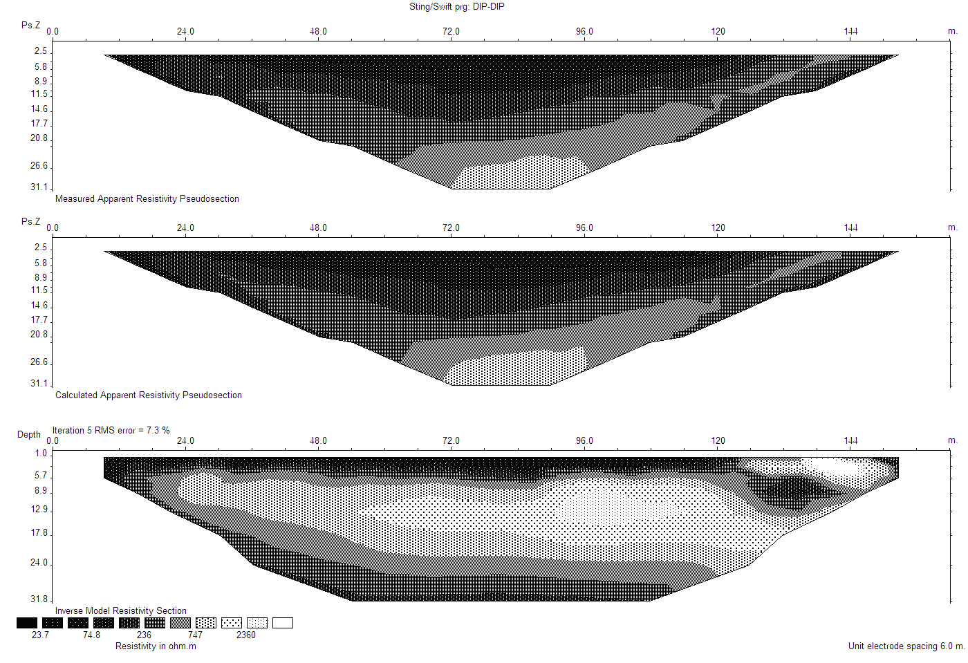
-975126.100
-975126.050
-975126.000
-975125.950
-975125.900
-975125.850
-975125.800
Station ID/Distance
Bouguer Gravity (mGal)
(157)
(177)
(197)
(216)
(236)
(256)
(276)
(295)
(315)
(335)
354)
(374)
(394)
(413)
(433)
(453)
(472)
(Feet)
LOW-GRAVITY
ANOMALY
OVER CAVE
48
54
60
66
72
78
84
90
96
102
108
114
120
126
132
138
144
Meters
HIGH-RESISTIVITY ANOMALY REVEALING CAVE
LOW-RESISTIVITY REVEALING REGOLITH ABOVE BEDROCK
Storm Sewer
0.0 (0.0)
24.0 (79)
48.0 (157)
72.0 (236)
120.0 (394)
144.0 (427)
Meters (Feet)
96.0
(295)
8.9
(29.2)
24.0
(78.7)
7.8
(58.4)
Depth
Meters
(Feet)
1.0
(3.3)
Iteration 5 RMS error= 7.3%
Calculated Apparent Resistivity Pseudosection
Inverse Model Resistivity Section
Resistivity in ohm.m
Unit electrode spacing 6.0 meters
LOCATION OF WELL DRILLED INTO CAVE
31.8
(104.3)
Figure 1. Lost River Cave located below Egypt Parking Lot by drilling a well into a low-gravity, high-resistivity anomaly.

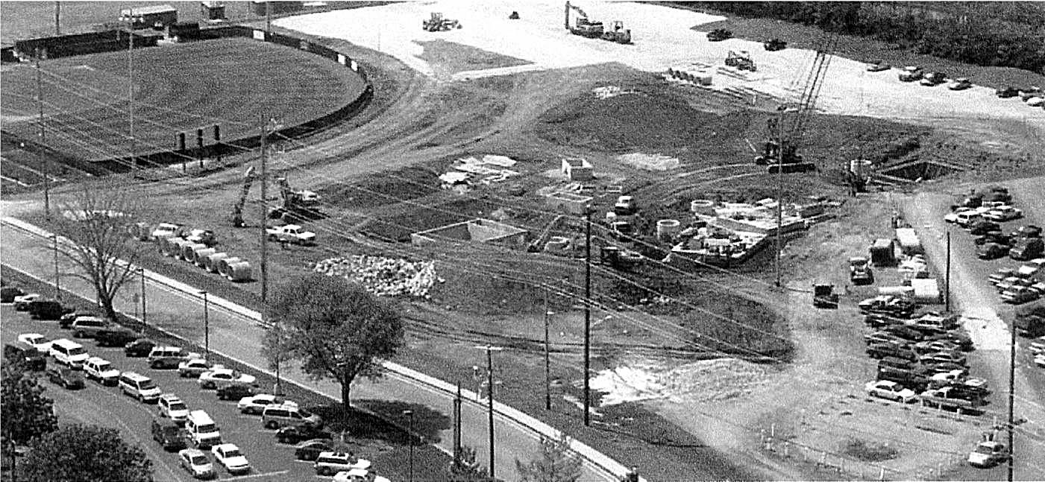
Figure 2. Aerial view of 4 Vortechs units being installed to treat storm water runoff before it is discharge into the Lost River through four 1.22 m (4 ft) diameter wells. Photography courtesy of Vortechnics, Inc.

control, forcing the high flow control to operate at full capacity. These unique chambers require periodic maintenance and inspections to guarantee their efficiency. In order to provide easier access for maintenance, Vortechnics has designed these chambers to be placed below a manhole cover. A vacuum truck is used to periodically remove the oil and grease and sediments from the units.

Case Study: Kentucky Trimodal Transpark

The Kentucky Trimodal Transpark is a new industrial park being built in Bowling Green above the Graham Springs Groundwater Basin. The CCKS under a grant to Western Kentucky University from the Inter-Modal Transportation Authority, performed the hydrogeologic investigation of the site (Crawford, 2003). Crawford recommended in the final report that extraordinary steps be taken to prevent sinkhole flooding and regolith collapse sinkholes and to protect the water quality of the Graham Springs karst aquifer. A storm water management system was proposed that would treat all storm water runoff from the roads, parking lots and buildings at the site while also providing emergency containment in the event of an accidental spill or leak of hazardous liquids. The recommended system included curbed streets and parking lots with storm sewers that would direct all storm water runoff into a treatment system that would separate oil and grease and settleable solids. The treated storm water runoff would then flow into a surface impoundment capable of holding the entire volume of runoff from a three-hour, 100-year storm. It was recommended that a synthetic liner be placed under the surface impoundment to prevent possible regolith collapse sinkholes. The surface impoundment would also serve to allow additional suspended sediments to settle out, thus providing secondary treatment for the storm water runoff since most contaminants are attached to suspended solids. Crawford also recommended that the water from the surface impoundment be spray irrigated either onto the green spaces required for the industrial park and/or adjacent farmland. This would allow the water to infiltrate and slowly percolate down through the soil into the karst aquifer and thereby be treated by soil treatment. Soil treatment is the method by which surface water is naturally cleaned as it percolates down to the water table throughout the world. The storm water treatment system would prevent direct recharge into the karst aquifer through sinkholes, and storm water would be treated by a three-phase system to remove contaminants before it percolated down into the karst aquifer. This system was designed by Mayes, Sudderth and Etheredge, Inc. and the proposed storm water treatment system was included in the binding elements for all impervious areas at the Transpark location (Figure 3).This system far exceeds what is required by government regulations. Hopefully, it will set an example for rigorous protection of groundwater quality for development upon both karst and porous media aquifers.

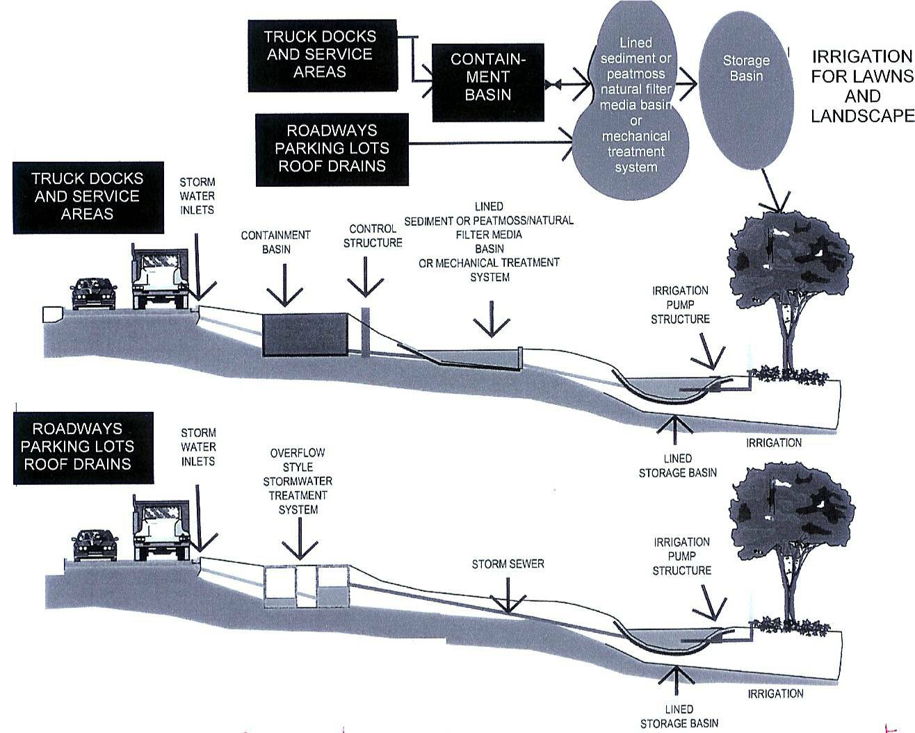

Figure 3. Required storm water runoff system for Transpark. Designed to: 1) provide tertiary treatment of storm water runoff, 2) contain spills of hazardous chemicals, 3) prevent sinkhole flooding, and 4) prevent storm water induced regolith collapse sinkholes. Design by: Mayes, Sudderth, and Etheredge, Inc.

References

Brewer, J.D. and Crawford, N.C. (2005). “Groundwater basin delineation by dye tracing, water table mapping, cave mapping, and geophysical techniques: Bowling Green, Kentucky, U.S.A.”, Proceedings of the 14th International Congress of Speleology, Athens, Greece.
Crawford, N.C. (1984). “Sinkhole flooding associated with urban development upon karst terrain: Bowling Green, Kentucky” in Beck (ed.), Sinkholes, Their Geology, Engineering and Environmental Impact, Rotterdam, Netherlands, A.A. Balkema Publishers, pp.283-292.
Crawford, N.C. (1988). Karst Hydrogeologic Problems of Southcentral Kentucky: Groundwater Contamination, Sinkhole Flooding, and Sinkhole Collapse, Guidebook for Second Conference on Environmental Problems in Karst Terranes and Their Solutions, sponsored by Association of Ground Water Scientists and Engineers, National Water Well Association, Nashville, Tennessee, U.S.A., 107 p.
Crawford, N.C. (2003). “Karst hydrogeologic investigation for proposed Kentucky Trimodal Transpark”, in Beck (ed.), Sinkholes and the Engineering and Environmental Impacts of Karst, Technical Publication #122, American Society of Civil Engineers, pp. 404-414.
Crawford, N.C., Fryer, S.E. and Calkins, C.A. (2000). “Geophysical techniques for locating and mapping caves from the ground surface: microgravity subsurface investigation of Egypt Parking Lot, Western Kentucky University”, Proceedings of Mammoth Cave National Park’s Eighth Science Conference, Mammoth Cave Nat’l Park, pp. 25-36.
Crawford, N.C., Lewis, M.A. and Webster, J.A. (1999). “Microgravity techniques for subsurface investigations of sinkhole collapses and for detection of groundwater flow paths through karst aquifers”, in Beck, Pettit and Herring (eds.), Hydrogeology and Engineering Geology of Sinkholes and Karst, Balkema, Rotterdam, pp. 203-218.
Vortechnics (2004) “Where the earth meets the sky: storm water treatment in a karst environment”, Project Profile by Vortechnics, Inc., 4 p.

